Sexton

John S Butler

## GENERATE DATA

You can also embed plots, for example:

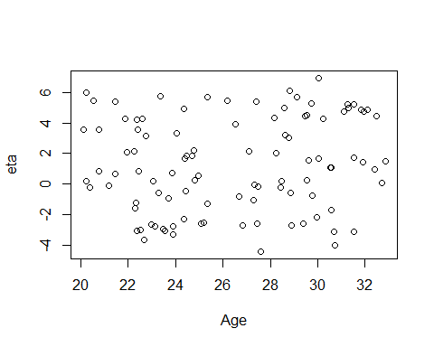

summary(Data)

## Conversion Age Distance Angle   
## Min. :0.00 Min. :20.10 Min. :10.12 Min. :-43.841   
## 1st Qu.:0.00 1st Qu.:23.11 1st Qu.:19.52 1st Qu.:-12.414   
## Median :1.00 Median :26.60 Median :34.39 Median : -3.034   
## Mean :0.63 Mean :26.42 Mean :33.64 Mean : -1.283   
## 3rd Qu.:1.00 3rd Qu.:29.65 3rd Qu.:47.17 3rd Qu.: 9.491   
## Max. :1.00 Max. :32.86 Max. :57.90 Max. : 31.484   
## Location   
## Away:53   
## Home:47   
##   
##   
##   
##

Sexton = glm(Conversion ~ Distance, data = Data,family=binomial("logit"))   
summary(Sexton)

##   
## Call:  
## glm(formula = Conversion ~ Distance, family = binomial("logit"),   
## data = Data)  
##   
## Deviance Residuals:   
## Min 1Q Median 3Q Max   
## -1.65217 -0.02453 0.00019 0.01864 1.90846   
##   
## Coefficients:  
## Estimate Std. Error z value Pr(>|z|)   
## (Intercept) 27.0106 9.3607 2.886 0.00391 **  
## Distance -0.6741 0.2339 -2.882 0.00396 **  
## ---  
## Signif. codes: 0 '***' 0.001 '**' 0.01 '*' 0.05 '.' 0.1 ' ' 1  
##   
## (Dispersion parameter for binomial family taken to be 1)  
##   
## Null deviance: 131.791 on 99 degrees of freedom  
## Residual deviance: 22.891 on 98 degrees of freedom  
## AIC: 26.891  
##   
## Number of Fisher Scoring iterations: 9

library(ggplot2)

## Warning: package 'ggplot2' was built under R version 3.6.1

ggplot(Data, aes(x=Distance, y=Conversion)) + geom_point() +   
 stat_smooth(method="glm", method.args=list(family="binomial"), se=FALSE)+xlab("Distance (m)")+ylab("Pr(Conversion)")+ theme(plot.title = element_text(hjust=1.0))+geom_vline(xintercept=50,col="black",size=1,linetype="dotted")+ geom_text(aes(x=53, label="Half Way Line", y=0.5),angle=90)+  
 geom_vline(xintercept=0,col="black",size=1,linetype="dotted")+ geom_text(aes(x=3, label="Goal Line", y=0.5),angle=90)

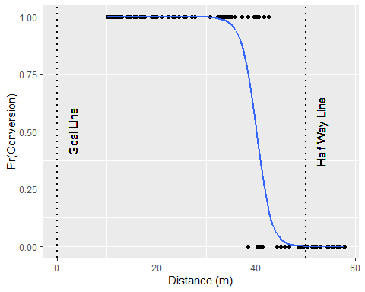

ggsave("Sexton.png",dpi=300, width = 4, height = 2.5)